By

*Muhammad Raees (*[*mr2714@rit.edu*](mailto:mr2714@rit.edu)*)*

*Asya Vitko (*[*av8258@rit.edu*](mailto:av8258@rit.edu)*)*

#### Overview

In this project, we aim to experiment with dimensionality reduction and classification methods on an image dataset. The data set contains 400 images of 40 subjects (10 images each) of a well-known AT&T face database. We implement dimensionality reduction using Principal Component Analysis (PCA) to extract eigenfaces (principal components) and then reconstruct faces to original dimensions from the reduced representation. Subsequently, we perform linear classification for face recognition and face identification. Additionally, we experiment with the Singular Value Decomposition (SVD) method for dimensionality reduction and K-Nearest Neighbors for recognition and identification.

#### Dimensionality Reduction

##### **2.1 PCA and Eigenfaces**

Figure 1 below shows the visualization of leading and trailing eigenfaces. The features of human faces are observable in initial eigenfaces (eyes, hairs, face parts, etc.). The importance of the eigenfaces decreases beyond the initial eigenfaces, reducing feature observability. The trailing eigenfaces do not provide a lot of information. Eigenfaces are sorted according to the variance they account for and contribute as less as we go towards trailing eigenfaces. Figure 2 below shows the significance of eigenfaces concerning their contribution to the cumulative variance. The importance of eigenfaces decreases slowly using SVD as compared to PCA.

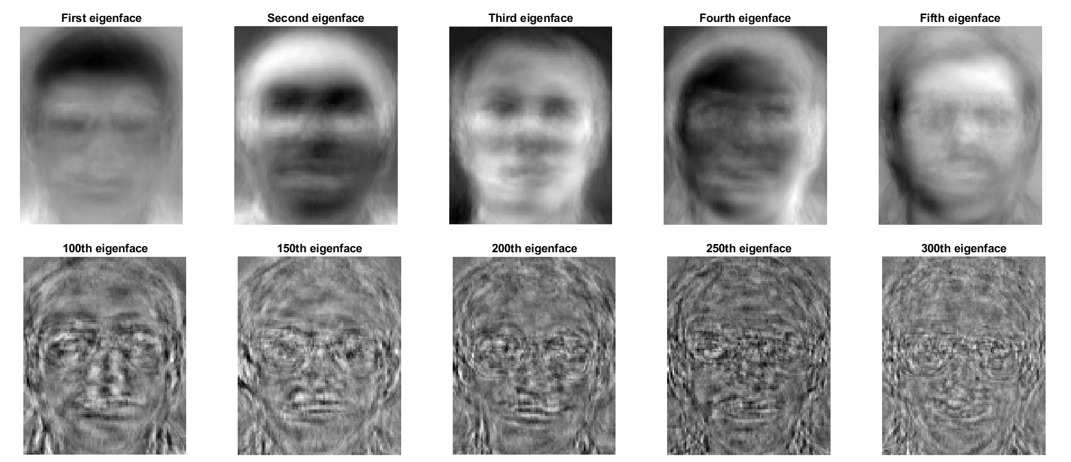

**Figure 1.** Comparison of how the (leading/trailing) eigenfaces look like an image.

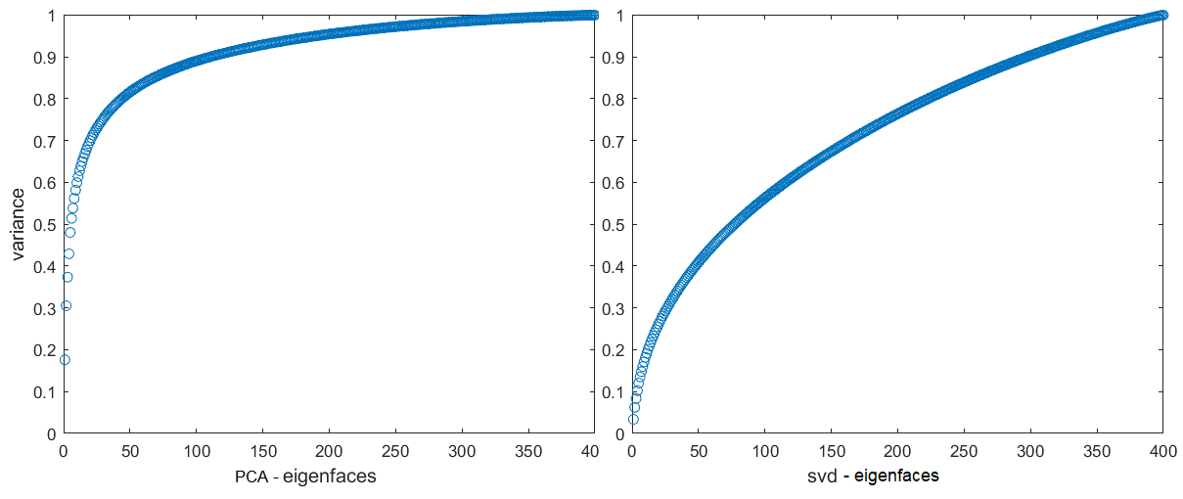

**Figure 2.** Comparison of how the importance of the eigenfaces decreases.

##### **2.2 Face Reconstruction with PCA**

We performed image reconstruction using various principal components and the sample reconstructions are shown in figure 3. Although images get clearer while using more and more eigenfaces, it is visually observable that lower eigenfaces do not contribute considerably towards reconstruction improvement. Also, in the last few reconstructions, there is no significant difference (i.e., eigenfaces 190 onwards). The variance graphs show an important metric (i.e., the variance) to estimate the reconstruction error. We estimate that around 110 components, constituting 90% of the variance for PCA (around 300 for SVD – as eigenface importance reduces more gradually for SVD), will be able to reconstruct the image with an acceptable error. Beyond this point, the reconstruction visuals do improve marginally but 90-95% variance preserving should reside in a reasonable error range for image features.

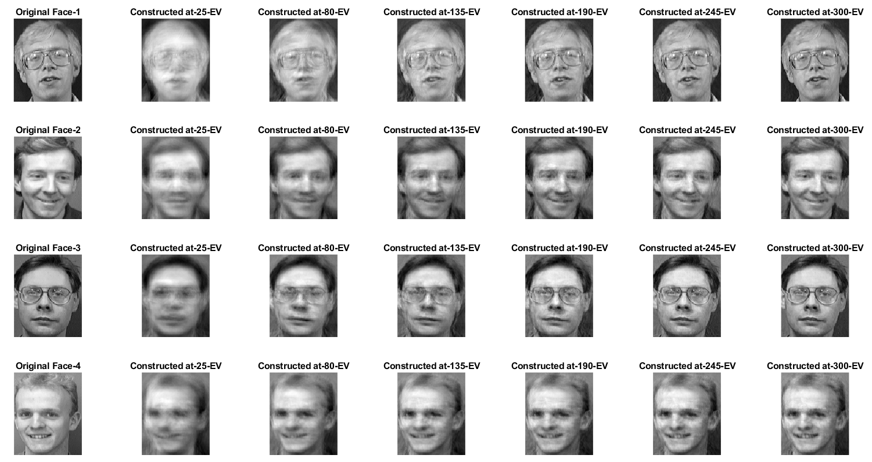

**Figure 3.** Face reconstruction on a subset of images using a different number of components.

#### Classification

We use linear and K-Nearest Neighbors (KNN) methods for face classification. The training set has images from 35 subjects and 8 images per subject and the test set has 2 images each for 35 subjects, 10 images for the other 5 subjects, and 15 non-face images.

##### **3.1 Face Recognition**

For face recognition, we recognize whether it is a face image or not after performing PCA on the training set that contains 280 face images. We test on the 120 test set face images, and 15 "non-face" images. The linear method gives a positive confidence score if it recognizes an image as a face. Along with the PCA, we use the KNN method for face recognition which performs better than the linear learning method. We used the maximum value of the distance between the neighbors as the threshold value to classify face and non-face images. The linear method did not perform well predicting many non-faces as faces and vice versa.

##### **3.2 Face Identification**

Like recognition, we employed face identification using linear classification and KNN methods to identify the class of a face it belongs to. For this task, the test set only contains 120 face images. We did not get a good score of accuracy on the classification task for both methods with KNN performing slightly better. Like recognition, the linear method provides confidence scores for 35 classes of faces. Table 1 below shows the comparison of the performance of both methods for recognition and classification tasks respectively. For this task, we also report reduced test set scores considering only the representative classes (35x2 images).

Table 1. Accuracy score of recognition and classification task.

|  |  |  |  |  |
| --- | --- | --- | --- | --- |
| ***Sr.*** | ***Method*** | ***Recognition Accuracy*** | ***Classification Accuracy*** | ***Classification Accuracy – Reduced*** |
| 1 | Linear Classification | 60% | 53% | 91% |
| 2 | K-NN | 89% | 56% | 96% |

#### Conclusion

We perform dimensionality reduction and image classification tasks using multiple methods. The eigenface decomposition PCA and Singular Value Decomposition PCA provide comparable performance for dimensionality reduction and image reconstruction. In PCA, the initial subset of eigenfaces has considerably higher variance (a metric for reconstruction error) preserved in comparison to SVD. However, we find that the SVD works much faster as compared to PCA due to reduced calculations. Using either method does not affect the accuracy of the classification models being used. The KNN models perform better in face recognition than the linear method. However, for face identification, there is no observable difference between both methods. We anticipate that the results can be improved by experimenting with complex models (e.g., higher-order polynomials) or using larger datasets.